Dokumentasi Report Transaksi Barang

Tampilan UI report Transaksi Barang

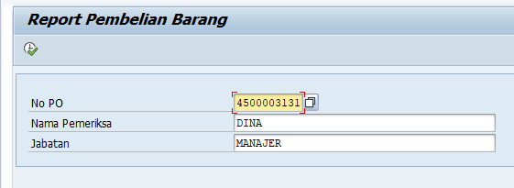

Data Report Transaksi Barang

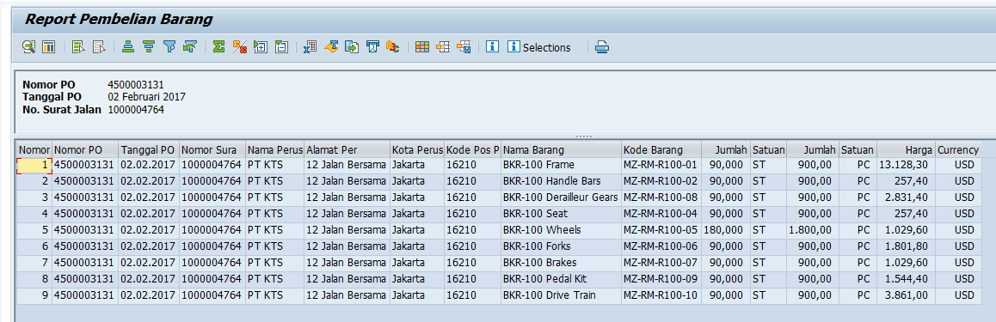

Smarform report transaksi barang

